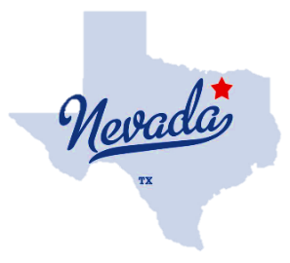
CITY OF NEVADA
424 E FM 6 NEVADA, TX 75173 | 972-853-0027

AGENDA

JOINT MEETING
IMPACT FEE COMMITTEE
PLANNING AND ZONING COMMISSION
Tuesday, January 25, 2022
7:00PM at City Hall

- Call to Order and Declaration of Quorums for both Impact Fee Committee and the Planning and Zoning Commission. In the event one of the two does not have a quorum, the other will proceed.

- Selection of Chair and Vice Chair of each of the Impact Fee Committee and the Planning and Zoning Commission

- Joint review of the duties of the Committee and the Commission. City Attorney
  - powers and duties
  - Zoning categories
  - Comprehensive Plan for the city
  - Master throughfare plan
  - Zoning plans
  - Required steps for each
  - Required steps for development of impact fees

- Status of city maps, planning. Engineering issues—City Engineer
5.. Public comment
Citizens are invited to address the meeting with public comments. Comments regarding items for which notice has not been given will be limited to three minutes. Responses shall be in accordance with Sec. 551.042 of the Texas Government Code. Comments regarding an item on the agenda may be given before or during discussion of that item when recognized by the Chair. An intentional act intended to disrupt a Government meeting is a violation of law.

12. Adjournment / Closing - Time: ______

I, Judy Hill, City Secretary, certify that the Agenda of the City of Nevada Impact Fee Committee and Planning and Zoning Joint Meeting to be held on January 25, 2022, was posted at City Hall on January 22, 2022.

JUDY HILL, CITY SECRETARY

NOTICE—A QUORUM OF CITY COUNCIL MEMBERS MAY ATTEND THIS MEETING.
IF SO, NO ACTION OR DELIBERATION IS SCHEDULED FOR THE COUNCIL

